## **WebRTC DEMO Setup** Initially, Connect your PCs into a HUB or Switch. Make sure your Wi-Fi connection is turned off.

**Step 1:** Navigate to “Settings” > “Network & internet” > “Advanced network settings” > “Wi-Fi” > “View additional properties”.

**Step 2:** On “IP Assignments” click “Edit” button. Then you will see a screen like below.  
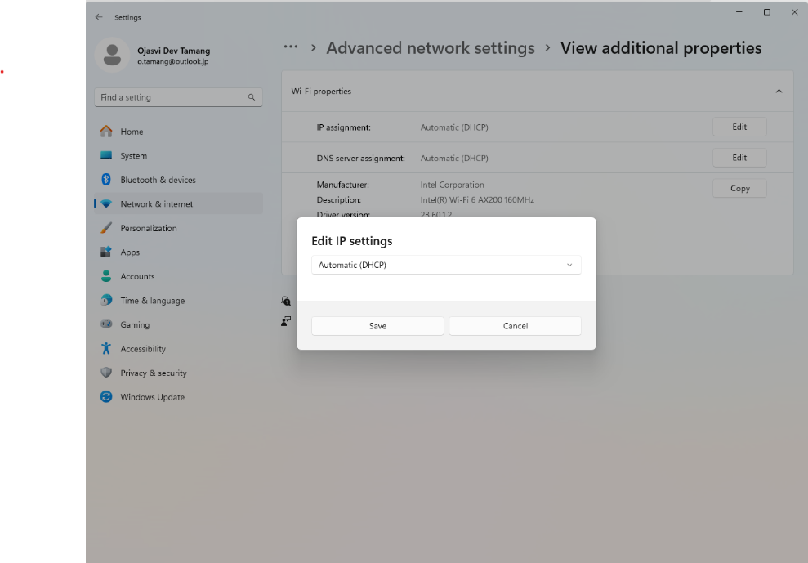

**Step 3:** Choose a “Manual” setting and switch on the “IPv4” and insert the “IP address” and “Subnet mask”. For example: 192.168.1.1 and 255.255.255.0  
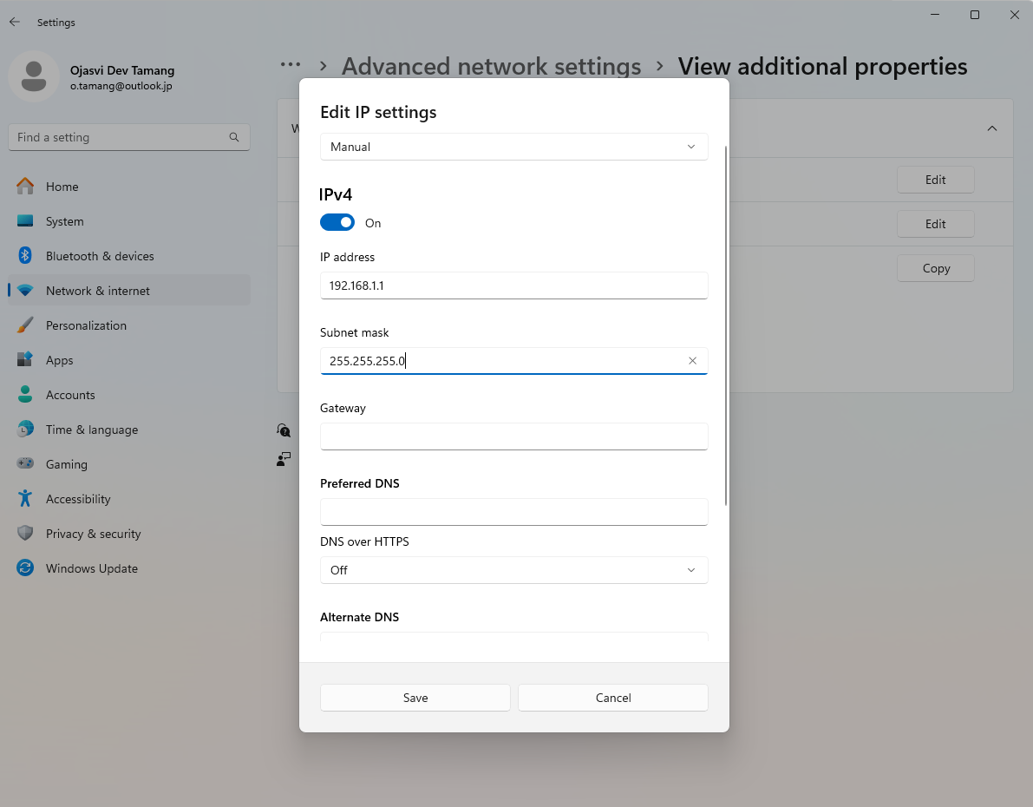  
Now, click “Save” button.

**Step 4:** Check if the above IP address and Subnet mask is implemented. Open “Command Prompt” and type “ipconfig”.  
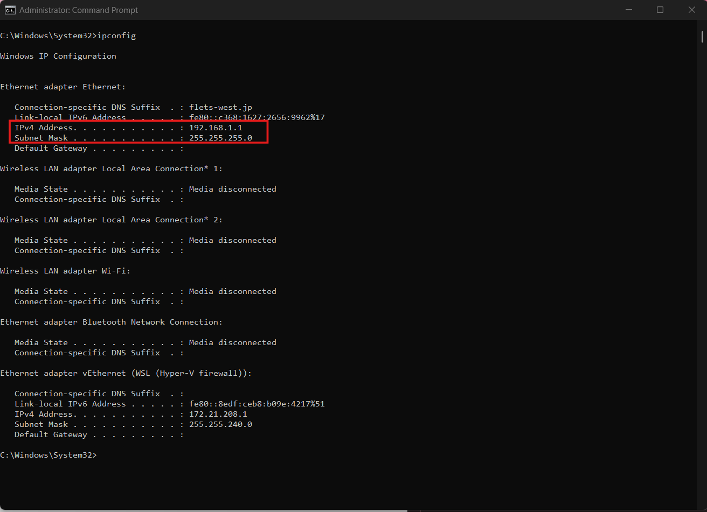

**Step 5:** Do similar steps 1, 2, 3 and 4 for another PC(PC2) as well. Be sure to insert the same “Subnet mask” as that of above PC or PC1(255.255.255.0). The IP Address on both PCs should be different. For example: IP Address for PC2: 192.168.1.2  
**Step 6:** Once Step 5 is done, you can check, if both PC1 and PC2 are connected, using ping command on your terminal. If you are checking from PC2, type “ping <IP address of PC1>” for example: “ping 192.168.1.1” or vice-versa. You should expect a response like below.  
**Step 7:** Once, both the PCs can communicate with each other, setup the DEMO code. For now, setup Sender and Signaling server on one PC and Receiver on another PC.   
[ojasvi264/webRTC-Sender-SignalingServer](https://github.com/ojasvi264/webRTC-Sender-SignalingServer) (Sender and Signaling server)  
[ojasvi264/webRTC-Receiver](https://github.com/ojasvi264/webRTC-Receiver) (Receiver)  
You might have to install web socket for signaling server, for which navigate to the file path(webRTC-Sender-SignalingServer/server/) and run “npm install ws”.  
  
**Step 8:** Now, on the signaling server, run command  
 “node signalingServer.js”  
 This will execute the signaling server.

For this Demo Project the first connection made to the “Signaling server” is the “Receiver”. So, whenever you start the connection make sure, the Receiver is connected first to the Signaling server.  
  
**Step 9:** Connect the receiver. Navigate to the file path (file:///D:/Projects/receiverRTC/receiver.html) where you have installed the Receiver and open the receiver.html file on any browser.

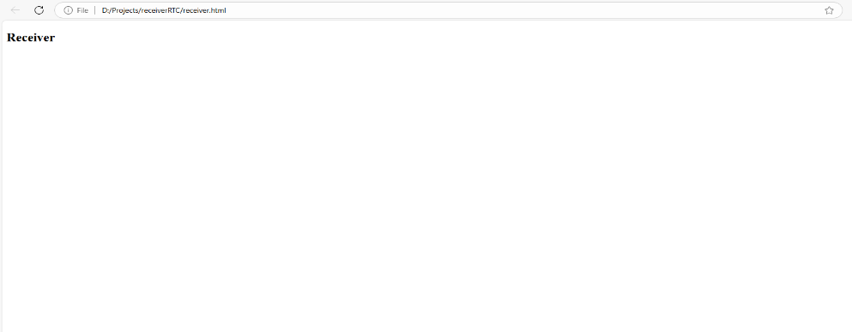

On the terminal where you have executed signaling server, you will get a response like below:  
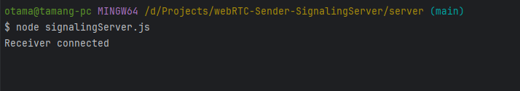

**Step 10:** Connect the Sender. Navigate to the file path (file:///D:/ Projects /webRTC-Sender-SignalingServer/sender.html) where you have installed the Sender and Signaling Server and open the sender.html file on any browser.

You will get a response like below:

**Step 11:** Once both the Sender and Receiver are connected, click “Start Call” button from the Sender.

**Step 12:** If you want to make connections with more than one sender, then execute the sender code on another PC, navigate to the file path and open sender.html on the browser. Then you can see a response like below.  
  
**Step 13:** On the Receiver screen you can see screen of both the senders.

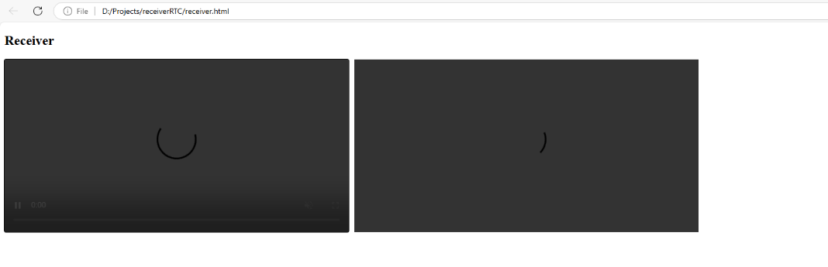  
**Issue**  
Since, there is no internet connection or the STUN or TURN server, I guess the Ice Candidates cannot be transmitted from one PC to another. So, we are unable to view the video.